This is just a section on the SNMP get request and responses but illustrates how additional requests sent from Observium because the MLX has not responded within 1 second results in longer waits for the SNMP requests queued up and so more additional requests for subsequent bulk requests.

Wireshark extract for optic OIDs showing three unique SNMP bulk get requests, Green, Red and Blue.

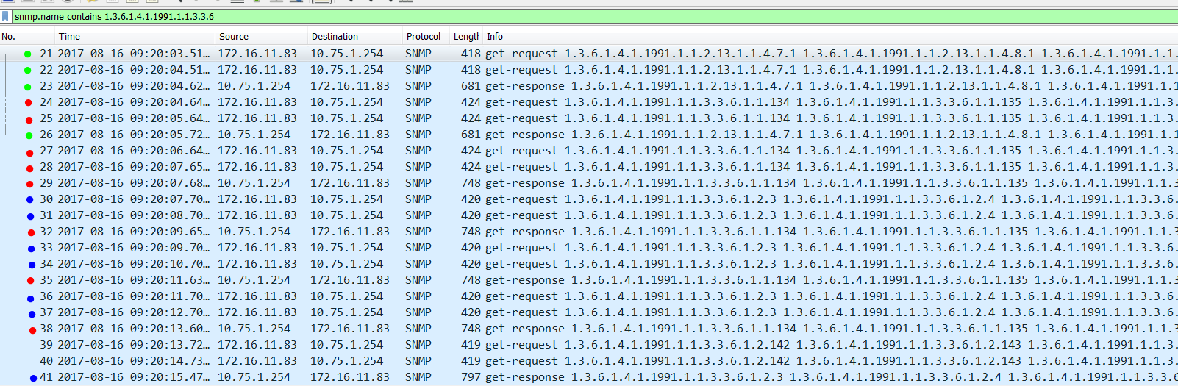

MLX SNMP debug details

Wireshark packet 21 sent 9:20:03.51 - BULK SNMP query Green Request

Aug 16 09:20:03.529 : 172.16.11.83: 1005260145: SNMP-V2 request: Get PDU with 16 varbind(s):

snAgentTempValue.7.1, snAgentTempValue.8.1, snAgentTempValue.9.1, snIfOpticalMonitoringTemperature.1,......., snIfOpticalMonitoringTemperature.130, snIfOpticalMonitoringTemper

MLX response wireshark pkt 23 - BULK SNMP query Green Response

Aug 16 09:20:04.617 : 172.16.11.83: 1005260145: SNMP response: GetResponse PDU with 16 varbind(s):

snAgentTempValue.7.1 = 104, snAgentTempValue.8.1 = 108, snAgentTempValue.9.1 = 101, snIfOpticalMonitoringTemperature.1 = " 44.3085 C: Normal",......., snIfOpticalMonitoringT

Wireshark pkt 22 sent 9:20:04.51 - BULK SNMP query Green Request

Aug 16 09:20:04.617 : 172.16.11.83: 1005260145: SNMP-V2 request: Get PDU Queue time = 90197 usec, Queued position = 1 with 16 varbind(s):

snAgentTempValue.7.1, snAgentTempValue.8.1, snAgentTempValue.9.1, snIfOpticalMonitoringTemperature.1,......., snIfOpticalMonitoringTemperature.130, snIfOpticalMonitoringTemper

MLX Response wireshark pkt 26 - BULK SNMP query Green Response

Aug 16 09:20:05.720 : 172.16.11.83: 1005260145: SNMP response: GetResponse PDU with 16 varbind(s):

snAgentTempValue.7.1 = 104, snAgentTempValue.8.1 = 108, snAgentTempValue.9.1 = 101, snIfOpticalMonitoringTemperature.1 = " 44.3242 C: Normal",......., snIfOpticalMonitoringT

Wireshark packet 23 sent 9:20:04.62 - BULK SNMP query Red Request

Aug 16 09:20:05.721 : 172.16.11.83: 377075744: SNMP-V2 request: Get PDU Queue time = 1084735 usec, Queued position = 1 with 16 varbind(s):

snIfOpticalMonitoringTemperature.134, snIfOpticalMonitoringTemperature.135, snIfOpticalMonitoringTemperature.136, snIfOpticalMonitoringTemperature.139,......., snIfOpticalMoni

MLX Response wireshark pkt 29 - BULK SNMP query Red Response

Aug 16 09:20:07.685 : 172.16.11.83: 377075744: SNMP response: GetResponse PDU with 16 varbind(s):

snIfOpticalMonitoringTemperature.134 = " 54.1484 C: Normal", snIfOpticalMonitoringTemperature.135 = " 53.0273 C: Normal", snIfOpticalMonitoringTemperature.136 = " 50.781

Wireshark packet 25 sent 9:20:05.64 - BULK SNMP query Red Request

Aug 16 09:20:07.686 : 172.16.11.83: 377075744: SNMP-V2 request: Get PDU Queue time = 2065377 usec, Queued position = 2 with 16 varbind(s):

snIfOpticalMonitoringTemperature.134, snIfOpticalMonitoringTemperature.135, snIfOpticalMonitoringTemperature.136, snIfOpticalMonitoringTemperature.139,......., snIfOpticalMoni

MLX Response wireshark pkt 32 - BULK SNMP query Red Response

Aug 16 09:20:09.655 : 172.16.11.83: 377075744: SNMP response: GetResponse PDU with 16 varbind(s):

snIfOpticalMonitoringTemperature.134 = " 54.1484 C: Normal", snIfOpticalMonitoringTemperature.135 = " 53.0273 C: Normal", snIfOpticalMonitoringTemperature.136 = " 50.812

Wireshark packet 27 sent 9:20:06.64 - BULK SNMP query Red Request

Aug 16 09:20:09.655 : 172.16.11.83: 377075744: SNMP-V2 request: Get PDU Queue time = 3050455 usec, Queued position = 2 with 16 varbind(s):

snIfOpticalMonitoringTemperature.134, snIfOpticalMonitoringTemperature.135, snIfOpticalMonitoringTemperature.136, snIfOpticalMonitoringTemperature.139,......., snIfOpticalMoni

MLX Response wireshark pkt 35 - BULK SNMP query Red Response

Aug 16 09:20:11.631 : 172.16.11.83: 377075744: SNMP response: GetResponse PDU with 16 varbind(s):

snIfOpticalMonitoringTemperature.134 = " 54.1484 C: Normal", snIfOpticalMonitoringTemperature.135 = " 53.8359 C: Normal", snIfOpticalMonitoringTemperature.136 = " 50.718

Wireshark packet 28 sent 9:20:07.65 - BULK SNMP query Red Request

Aug 16 09:20:11.632 : 172.16.11.83: 377075744: SNMP-V2 request: Get PDU Queue time = 4043696 usec, Queued position = 3 with 16 varbind(s):

snIfOpticalMonitoringTemperature.134, snIfOpticalMonitoringTemperature.135, snIfOpticalMonitoringTemperature.136, snIfOpticalMonitoringTemperature.139,......., snIfOpticalMoni

MLX Response wireshark pkt 38 - BULK SNMP query Red Response

Aug 16 09:20:13.605 : 172.16.11.83: 377075744: SNMP response: GetResponse PDU with 16 varbind(s):

snIfOpticalMonitoringTemperature.134 = " 53.3945 C: Normal", snIfOpticalMonitoringTemperature.135 = " 53.0273 C: Normal", snIfOpticalMonitoringTemperature.136 = " 50.875

Wireshark packet 30 sent 9:20:07.70 - BULK SNMP query Blue Request

Aug 16 09:20:13.605 : 172.16.11.83: 839046562: SNMP-V2 request: Get PDU Queue time = 5995718 usec, Queued position = 3 with 16 varbind(s):

snIfOpticalMonitoringTxPower.3, snIfOpticalMonitoringTxPower.4, snIfOpticalMonitoringTxPower.65, snIfOpticalMonitoringTxPower.66,......., snIfOpticalMonitoringTxPower.135, snI

MLX Response wireshark pkt 41 - BULK SNMP query Blue Response

Aug 16 09:20:15.474 : 172.16.11.83: 839046562: SNMP response: GetResponse PDU with 16 varbind(s):

snIfOpticalMonitoringTxPower.3 = " -002.4972 dBm: Low-Alarm ", snIfOpticalMonitoringTxPower.4 = " -002.5367 dBm: Normal", snIfOpticalMonitoringTxPower.65 = " 001.0913 dBm: No

This selection is 3 requests. The MLX took about 2 seconds to respond to each individual SNMP request. So this should take 6 seconds but as the additional requests increase it has taken 12 seconds

This queue builds up as we can see later a request sent at

09:20:19 Observium does not see the response until 09:20:34 because it has sat in the queue on the MLX for all that time behind additional requests that weren’t necessary.

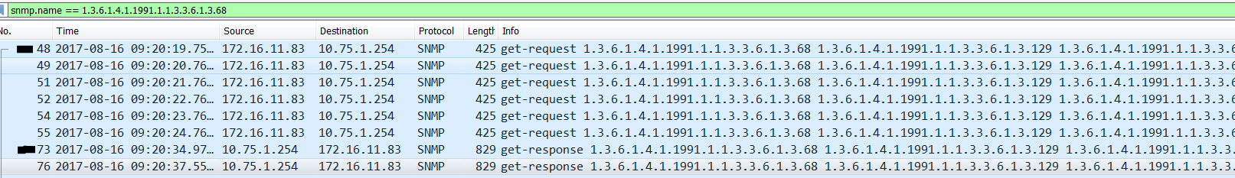

Packet 48

Aug 16 09:20:32.395 : 172.16.11.83: 845187701: SNMP-V2 request: Get PDU Queue time = 12838101 usec, Queued position = 9 with 16 varbind(s):

snIfOpticalMonitoringRxPower.68, snIfOpticalMonitoringRxPower.129, snIfOpticalMonitoringRxPower.130, snIfOpticalMonitoringRxPower.131,......., snIfOptic

Packet 73

Aug 16 09:20:34.972 : 172.16.11.83: 845187701: SNMP response: GetResponse PDU with 16 varbind(s):

snIfOpticalMonitoringRxPower.68 = " -002.5251 dBm: Normal ", snIfOpticalMonitoringRxPower.129 = " -009.5821 dBm: Normal ", snIfOpticalMonitoringRxPower.

Aug 16 09:20:34.972 : 172.16.11.83: 845187701: SNMP-V2 request: Get PDU Queue time = 14440725 usec, Queued position = 10 with 16 varbind(s):